**VISVESVARAYA TECHNOLOGICAL UNIVERSITY**

**“JnanaSangama”, Belgaum -590014, Karnataka.**



**LAB REPORT**

**on**

**COURSE TITLE**

***Submitted by***

**POOJA K(1BM19CS111)**

***in partial fulfillment for the award of the degree of***

**BACHELOR OF ENGINEERING**

***in***

**COMPUTER SCIENCE AND ENGINEERING**



**B.M.S. COLLEGE OF ENGINEERING**

**(Autonomous Institution under VTU)**

**BENGALURU-560019**

**May-2022 to July-2022**

**B. M. S. College of Engineering,**

**Bull Temple Road, Bangalore 560019**

(Affiliated To Visvesvaraya Technological University, Belgaum)

**Department of Computer Science and Engineering**



**CERTIFICATE**

This is to certify that the Lab work entitled “LAB COURSE **OBJECT ORIENTED MODELLING AND DESIGN**” carried out by POOJA K**(1BM19CS111),** who is bonafide student of **B. M. S. College of Engineering.** It is in partial fulfillment for the award of **Bachelor of Engineering in Computer Science and Engineering** of the Visvesvaraya Technological University, Belgaum during the year 2022. The Lab report has been approved as it satisfies the academic requirements in respect of a Course  **OBJECT ORIENTED MODELLING AND DESIGN**” **- (20CS6CPOMD)** work prescribed for the said degree.

Dr. Nandini vineeth               **Dr. Jyothi S Nayak**

Assistant professor Professor and Head

Department of CSE Department of CSE

BMSCE, Bengaluru BMSCE, Bengaluru

`

**Index Sheet**

|  |  |  |
| --- | --- | --- |
| **Sl. No.** | **Experiment Title** | **Page No.** |
| **1** | **College information system** | **4-5** |
| **2** | **Hostel management system** | **6-7** |
| **3** | **Stock maintenance system** | **8-9** |
| **4** | **Coffee vending machine** | **10-11** |
| **5** | Online shopping system | **12-13** |
| **6** | **Railway reservation system** | **14-15** |
| **7** | **Graphics editor system** | **16-17** |
|  |  |  |
|  |  |  |
|  |  |  |
|  |  |  |

POOJA K

1BM19CS111

Lab 1

College information system

Class_diagram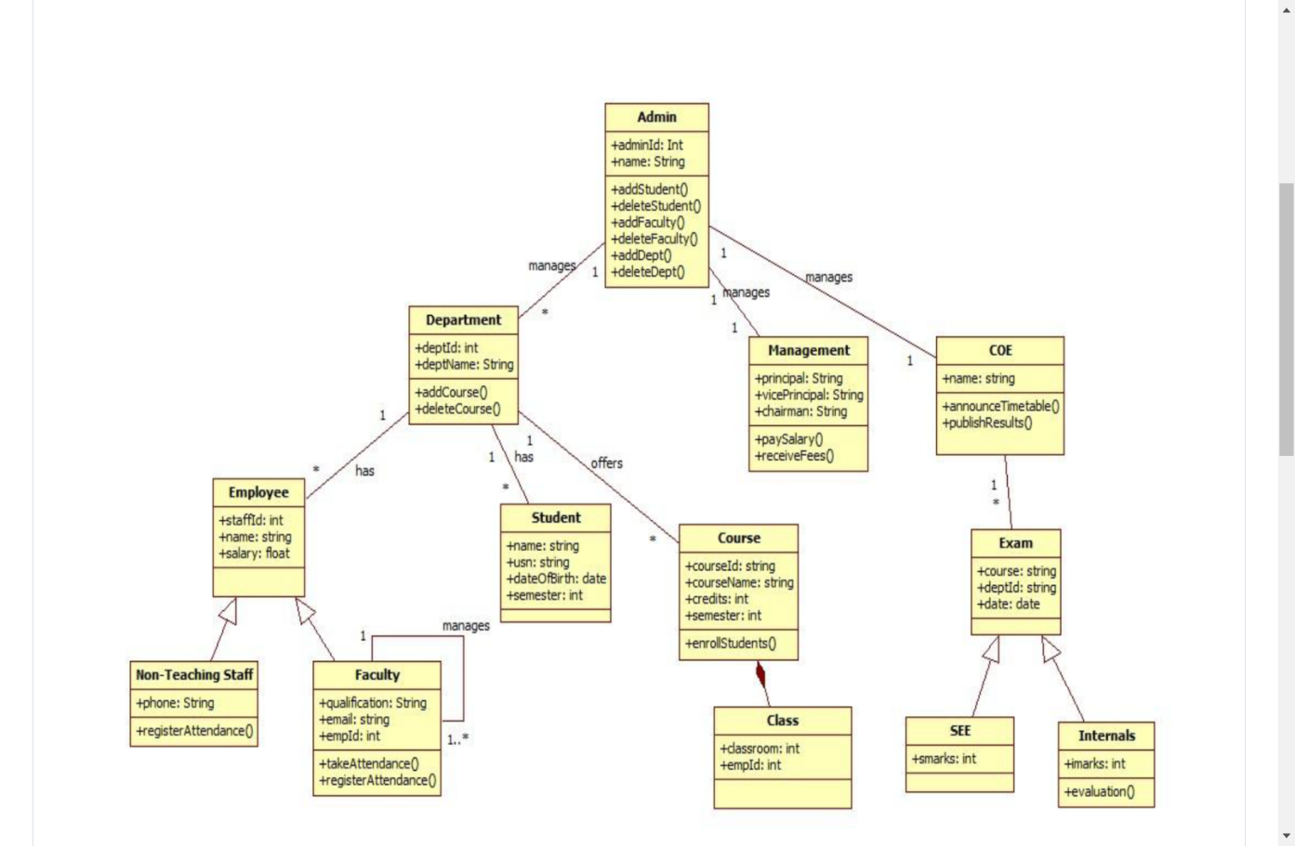● Admin is associated with student and staff. One admin manages many students and staffs in college.

● student is associated with admission, examination and Course. Student does admission once and takes many courses.

● staff is aggregation of non-teaching staff and faculty.Faculty is self associated.

● a department can have many faculties and is associated as such.

● Exam is generalized into SEE and Internals as they use all the attributes of Exam.

State diagram

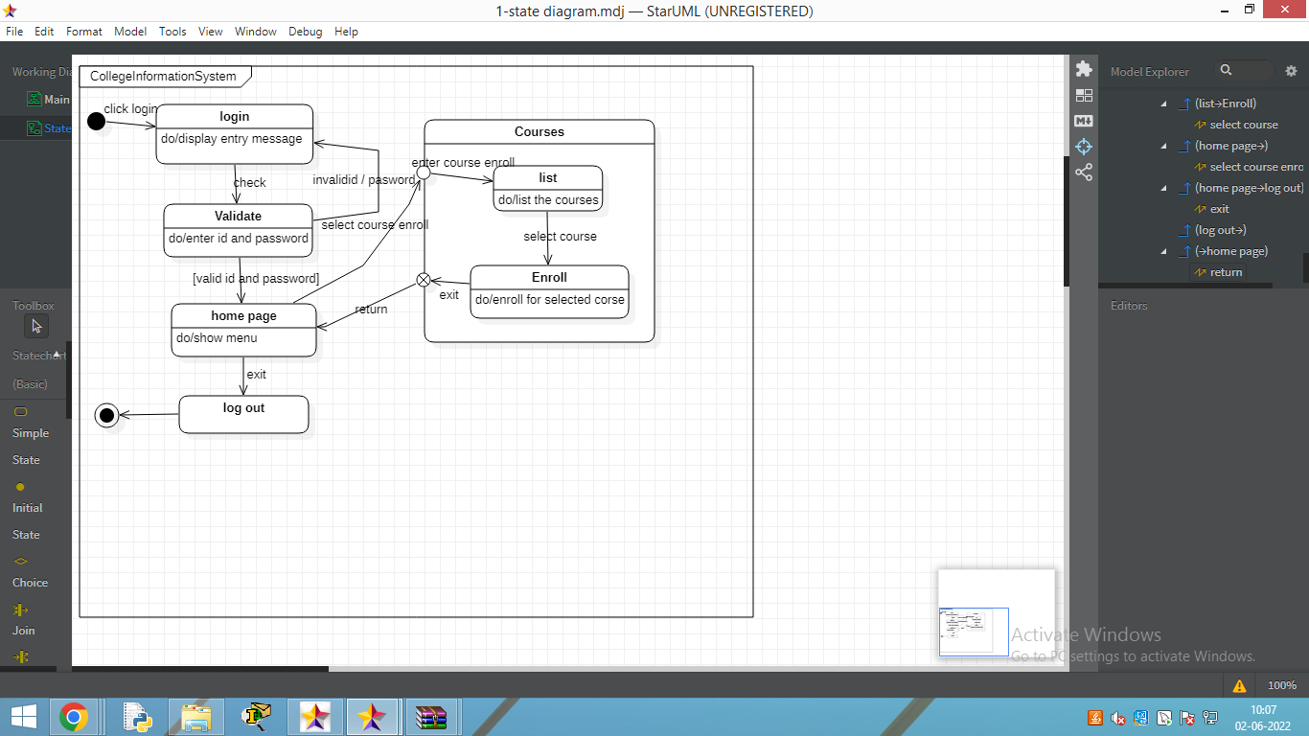

Lab 2

Hostel management system

Class diagram

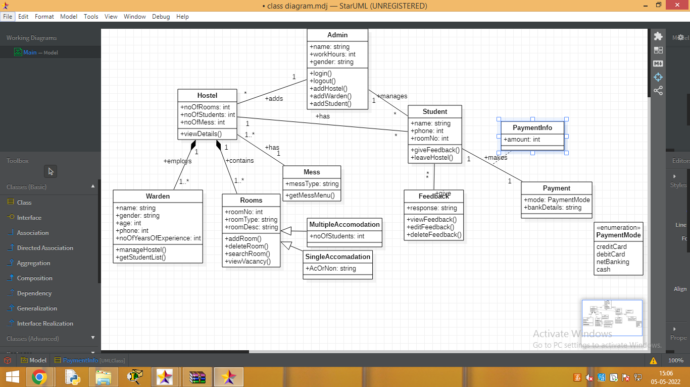●

Here we have an Admin class that has an association with Student, and Hostelclass. One admin can add zero or more students and can control many hostels.

● The hostel class is made up of the composition of Warden class and rooms as warden class and rooms class cannot exist without a hostel.Many hostels can have one or more warden.hostel class is associated with mess and 1 hostal has one mess. ● The Students make payment via available modes giving their bank details, here payment info is association class which gives info how much payment is to be done by that particular student

● Room clss is generalized to single accommodation and multiple accommodation rooms

State diagram

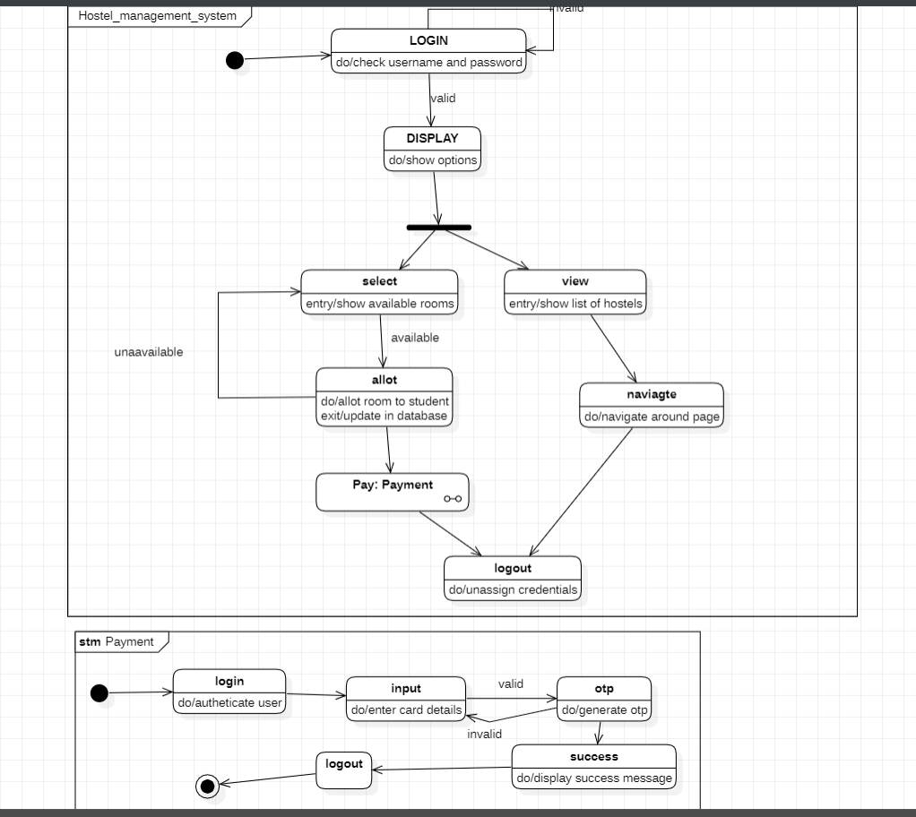

Lab 3

Stock maintenance system

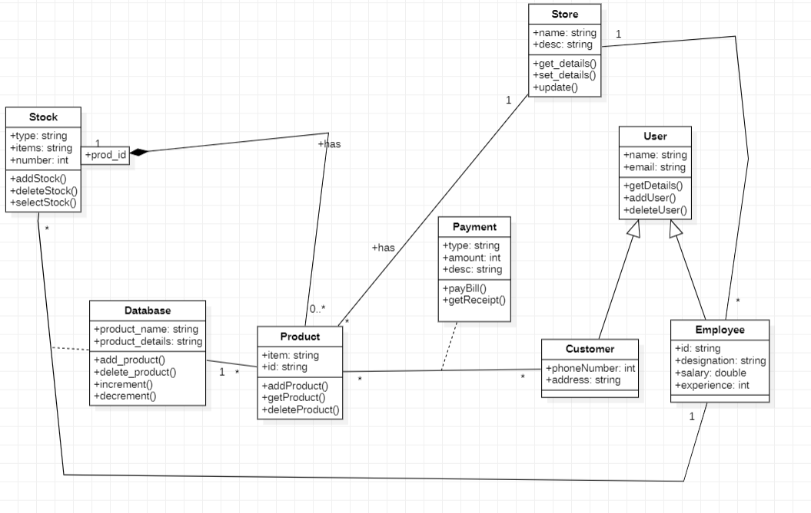Class diagram

* store has association with product and employee, 1 store can have many products and employees.

* stock is composition of 0 to many products.

* Payment done by the customer cannot be added to either product and customer and hence is a association class.

* database is a association class between stocka nd employee because it has details about the product. Hence product class is association with database too.

* user is generalized as customer and employee.

State diagram

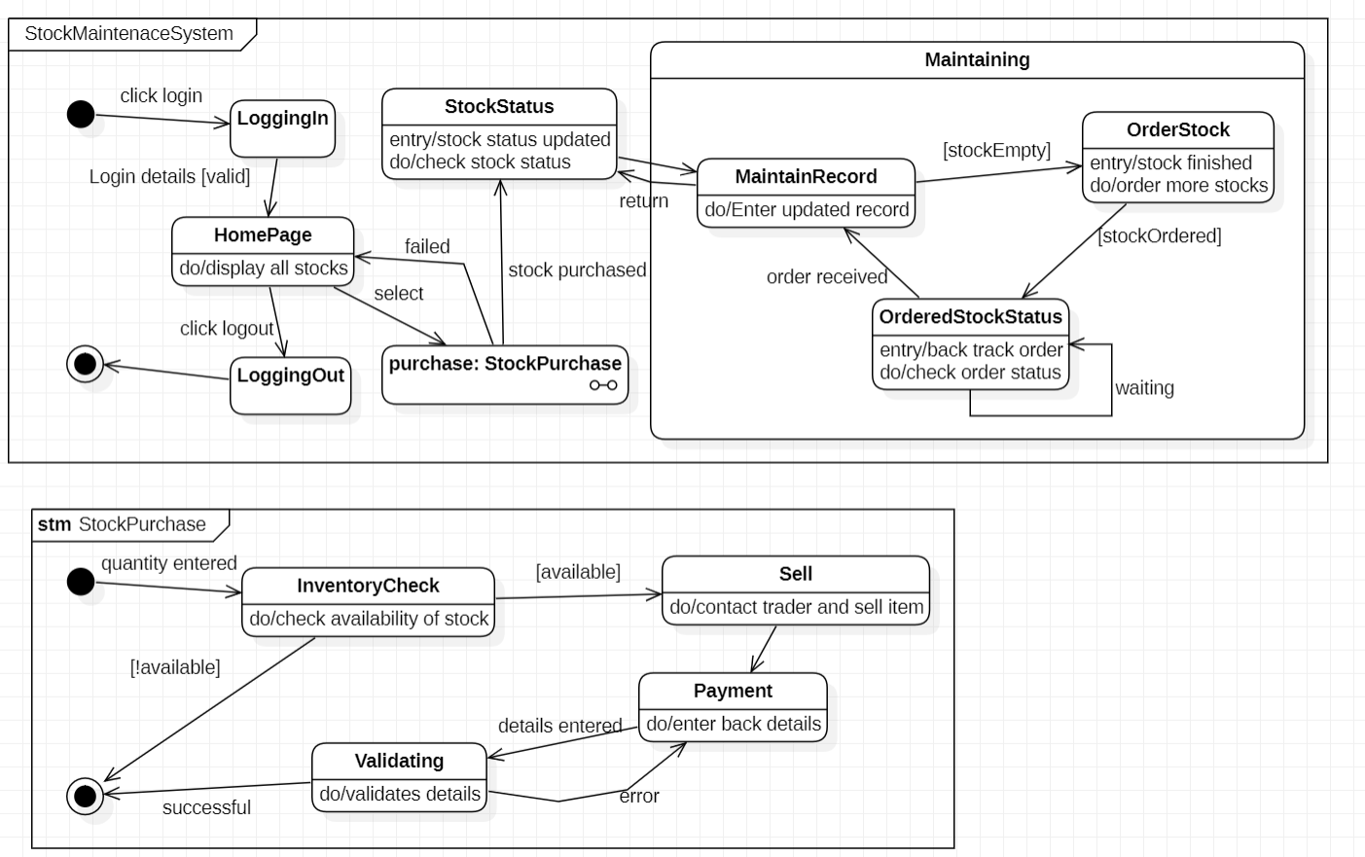

Lab 4

Coffee vending machine

Class diagram

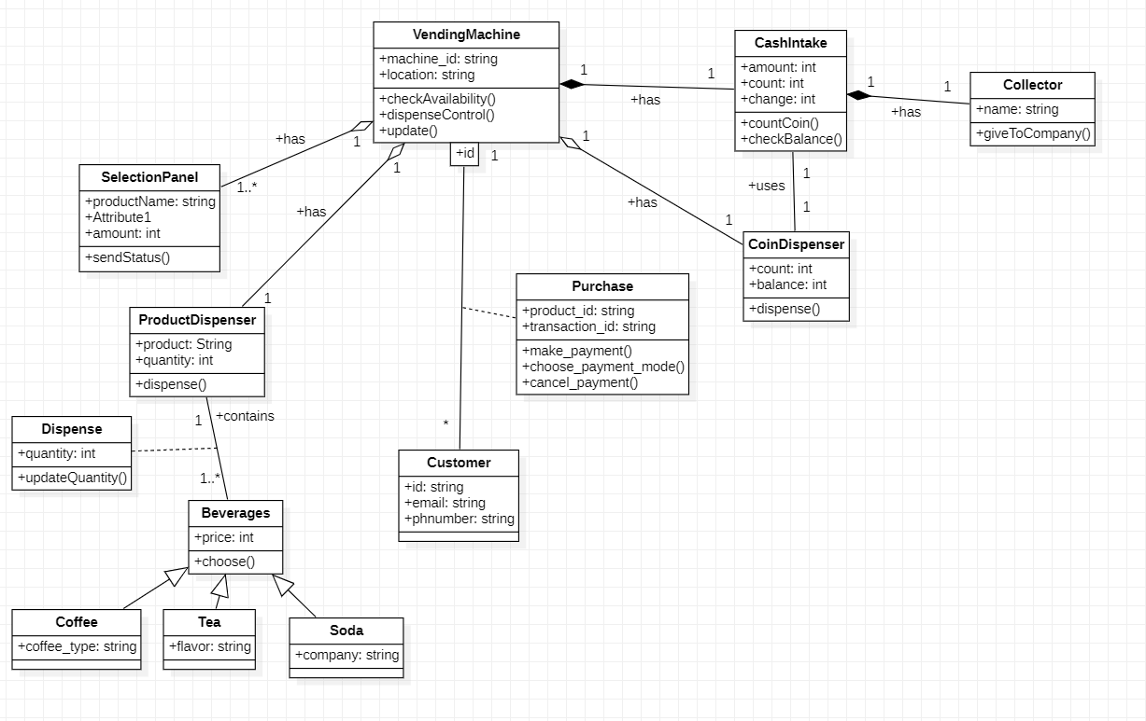

* vending machine is aggregation of selection panel, product dispenser, coin dispenser and Cash intake as they are all parts of the vending machine. Here cash intake is composition because it cannot exist without vending machine.

*cash intake and coin dispenser are associated because based on cash intake balance will be given back.

*purchase is a association class between customer and vending machine, it has details of the product customer has purchased.

*cash intake is composition of collector as collector can exist without it.

* coffee, tea and soda are generalized as beverages. Product dispenser is associated with becerages and quantity of that beverage is taken in a association class dispense as it can't be included in either calsses

State diagram

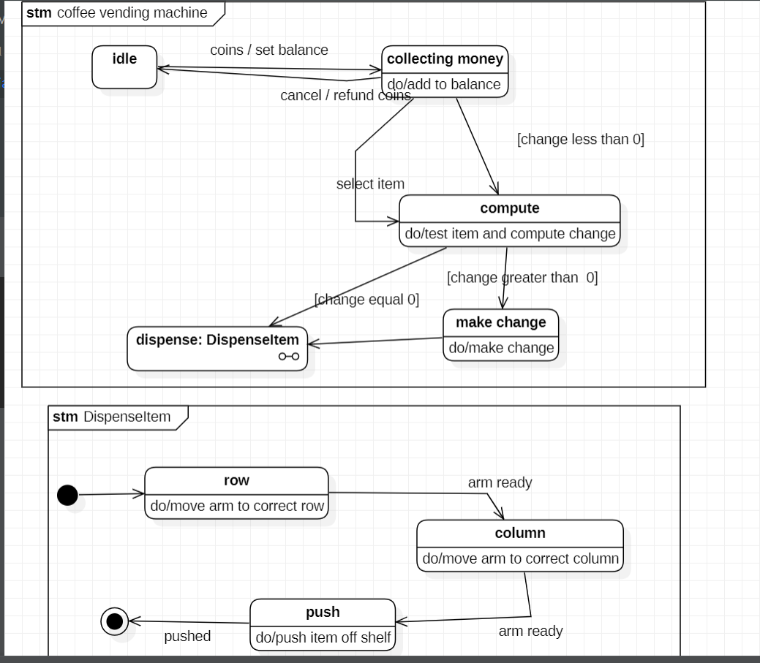

Lab 5

Online shopping system

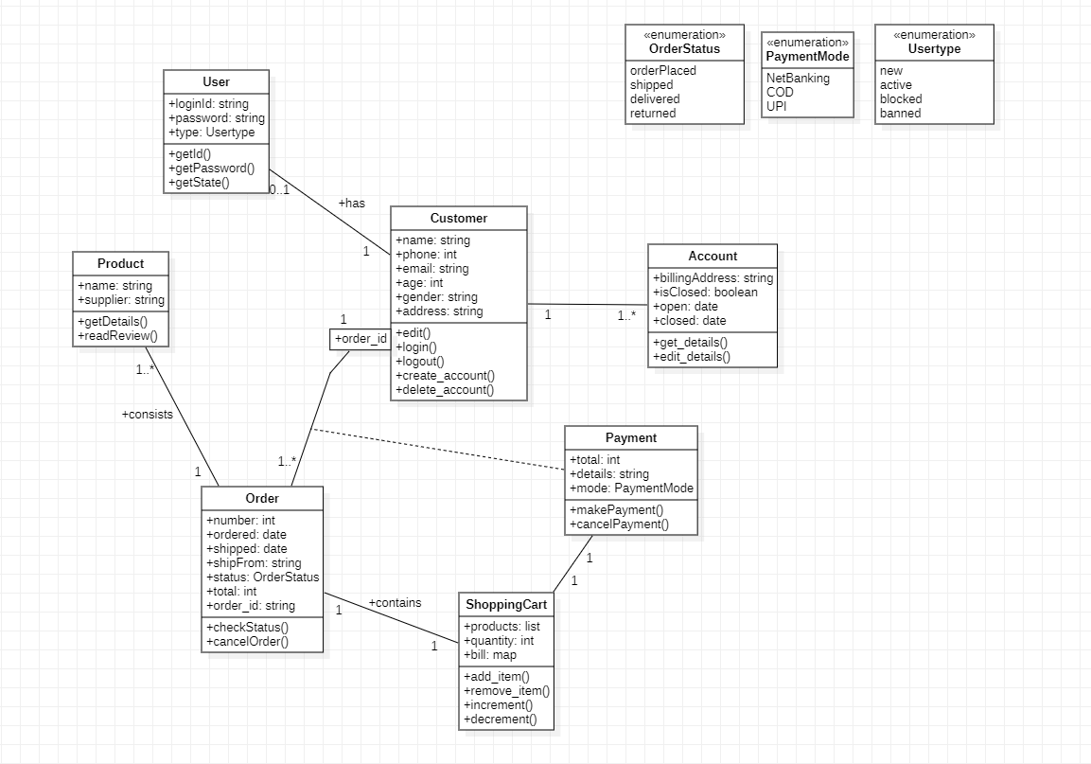Class diagram

* here customer is associated with user account and orderhere order id is specialized so that a single order id of a customer is associated with a single order.

*payment done for a order is a association class because it can't be included in order or customer.

*orderstatus, payment mode, usertype are enumeration because can have different state and different mode. An order contains shopping cart and is associated with a single payment for that cart.

State diagram

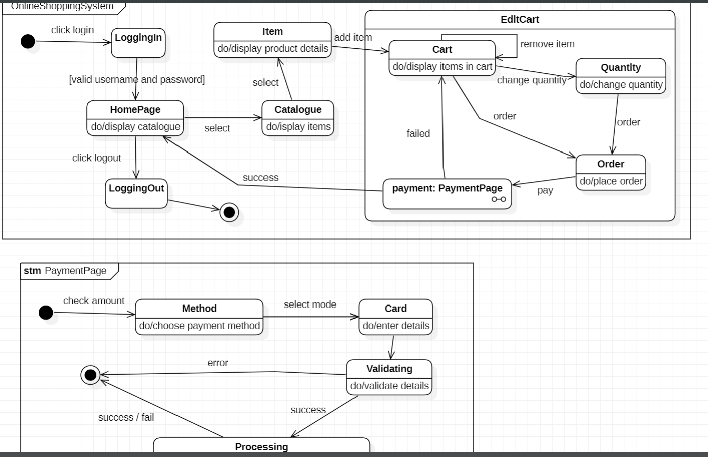

Lab 6

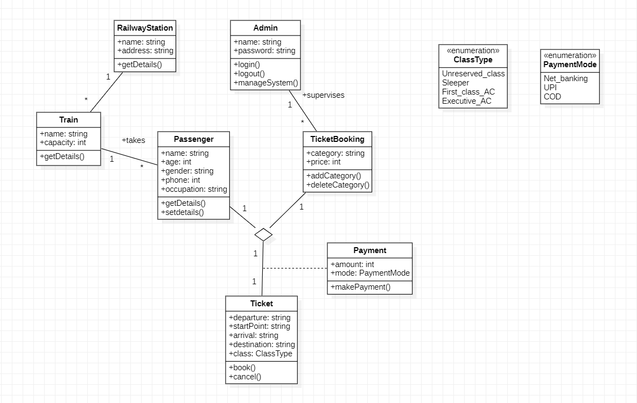Railway reservation system

Class diagram

*here passenger, ticket booking and ticket have multiple association because we need a single association between a pair of classes.

* payment is a association class because it can't be included in any class and is for a single travel.

* train is associated with railway station and passenger and 1 station has many trains and one train can accommodate many passengers.

*classtype and payment mode are enumeration with different options or modes

State diagram

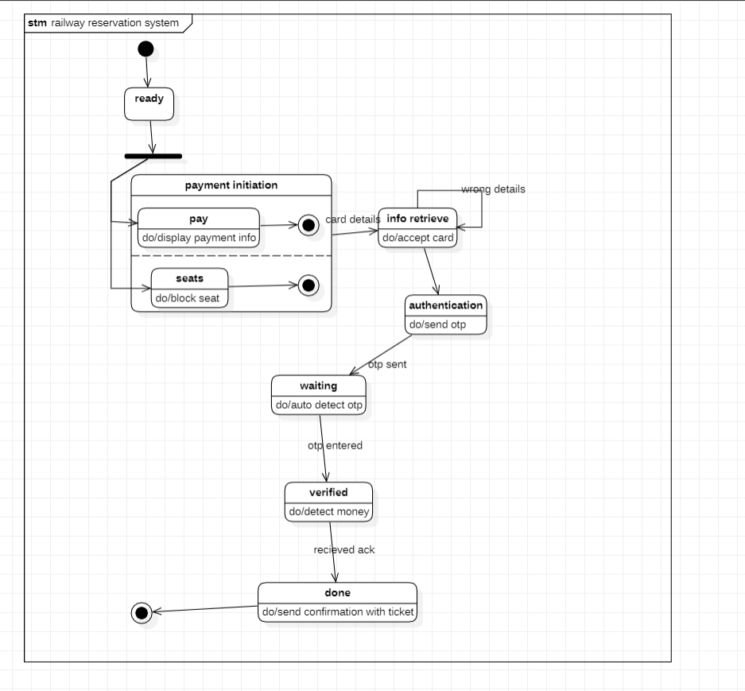

Lab 7

Graphics editor system

Class diagram

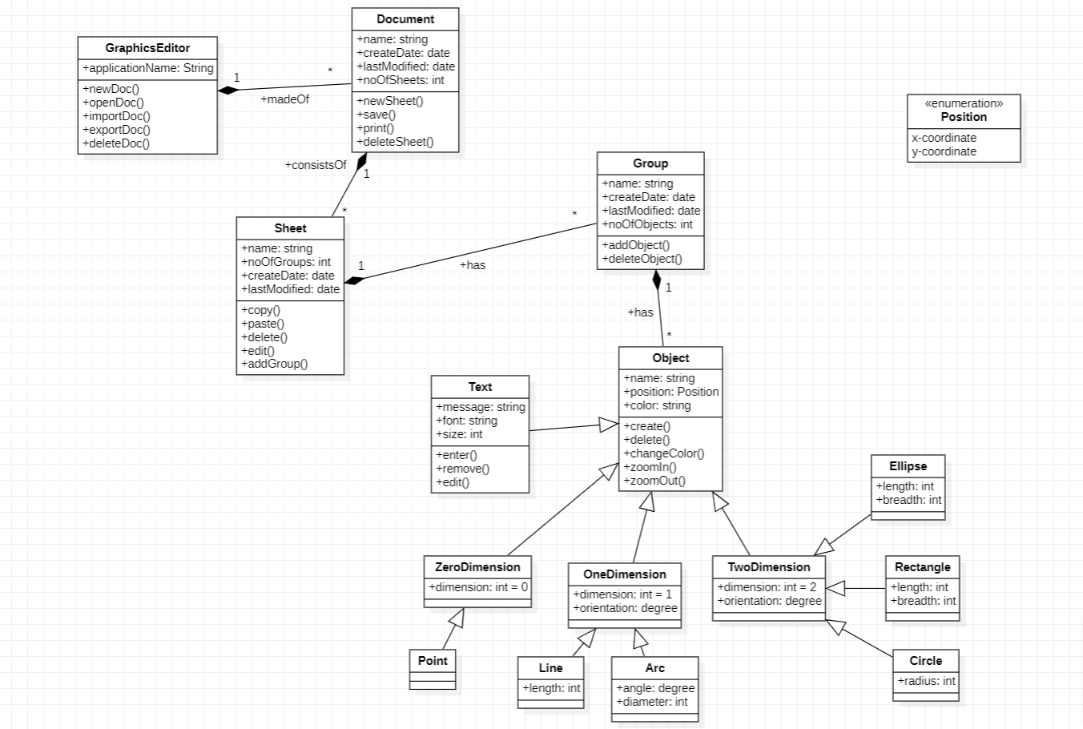

* graphics editor is the composition of many documents. Document is composition of sheet, sheet composition of group, group composition of objects respectively. Class that composes another class in all these cases cannot exist independently.

* text, zero dimension, one dimension and two dimension are inherited from object class.

*point is inherited from zero dimension, line and arc from one dimension and ellipse, rectangel and circle from two dimension respectively. It is because all inherited classes are types of the generalized class.

*position is a enumeration with x coordinate and y co ordinate.

State diagram

